Wednesday Nov 18 Your sister is prepping for Cheer tryouts at Laney tomorrow. She had a practice at Cheer Infinity so I went to Old Time Pottery because it's too dark to exercise at night. I looked at giant blow ups for the front yard because Sophia keeps telling me I need to be more festive. I almost bought a giant snowman or penguins (I will include the pictures) luckily, I didn't because Sophia says blows up are cheesy and I need to find something more classic and simpler. So your sister is being her moody, Bitchy self like when she is prepping for competition. Coach Ashley will be at the try out so that is adding pressure on her because she has always been so strict with Sophia. So last night I thought of you and how proud of her you were when she performed for the first time and they won! You were at an age where you weren't too cool to still hang around your parents and you saw your sister’s accomplishments as your own too! In the same moment I thought about her last competition. It was probably the worst all of us had seen in VA Beach and you were like I don't want to be here. That was the weekend you told your Dad and I you wanted to join the military and I think I had a rock in my stomach the whole weekend. You didn't know it but you were dressed so cool in the bomber jacket, cool sweats and the black toboggan you have a great sense of style and you were forced to spend time with us lol. Funny none of us realized then you would be in the Great Lakes for Thanksgiving. Angel told me you were miserable lol watching little girls compete in a cheer competition lol Funny you turned around a month later and went to Myrtle to watch her Dance competition same thing just girls your age. So Sophia being her moody self-right now with tryouts tomorrow I can hear you say Sophia stop being a little Bitch .. but her response to your this time might be Gus I need to put pressure on myself I perform better under pressure. That’s what she said to me last night. I truly hope we get to see here in Laney Cheer uniform and tryouts are political. She did say the Cheer coach mentioned she knew her brother had played football at Laney.
Thursday Nov 19, I drove your car to work today. I have been driving it a bit because I had to get it inspected and registration updated. Funny thing is those air fresh tree’s I keep taking them down because it makes me feel like I'm in a teenager's car and someone keeps putting them back up on the mirror lol. Sophia says the Car smells like you with them up hahahaha. I posted on my Instagram story a video of those trees in your car this morning and some crazy rap and tagged KND_Boys. So I have been wearing your apple watch and I guess when it's connected to the internet it gets text messages on it. The only ones that have come through are from the KND group. One about gaming the other was from Kevin with a music clip he made asking the group to rate it. I listened to it wasn't really good and TY_Savage rated as a 6 so I wasn't alone in thinking it kind of sucked lol I started thinking about your room again and what I’m going to do with the flooring, I'm waiting on some money to come in because I hate paying for things on credit but I found a few boxes of hardwood in the attic and though maybe I could do the stairs in hardwood and the room in carpet. Either way I'm gonna try and paint the hallway up the stairs and patch the holes in the wall this weekend. If I get really motivated, I might pull the carpet up off the stairs! Uncle Greg is coming for Thanksgiving and bringing his girlfriend of course hasn't given me any dates of arrival or departure so crazy how you two are very similar and always keep me on a need to know basis. He asked me for your social yesterday I gave it to him and asked him why and he didn't respond to me. Made me wonder if you had done your run test yet and what your numbers looked like. Remember the night you got drunk and acted like an ass to me? And I made you run the next day and you said maybe I shouldn't go in the Navy because I can't get the rundown? Was the dumbest thing to say when your numbers would always look good at the end of a track season when you had been practicing and were conditioned. I need to Jump back into work hoping my next letter brings you some good news, on your sister making Laney cheer. Love you kid and I know your pushing through and learning some crazy cool things we miss you more than you'll ever know but you are exactly where you need to be:) Love you Mom
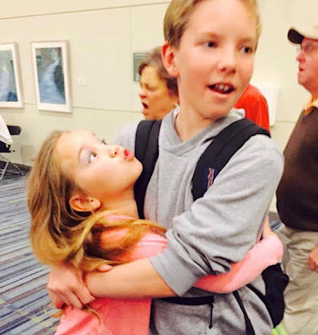 First Cheer Competion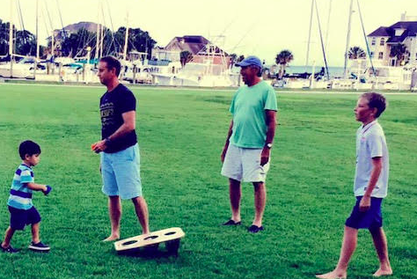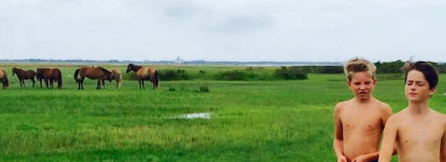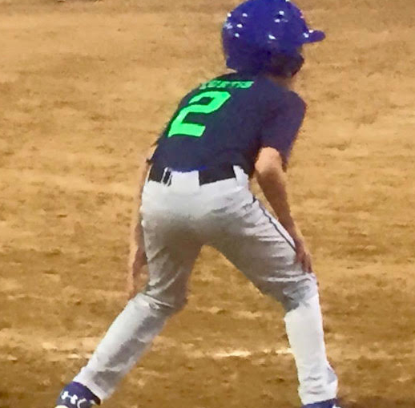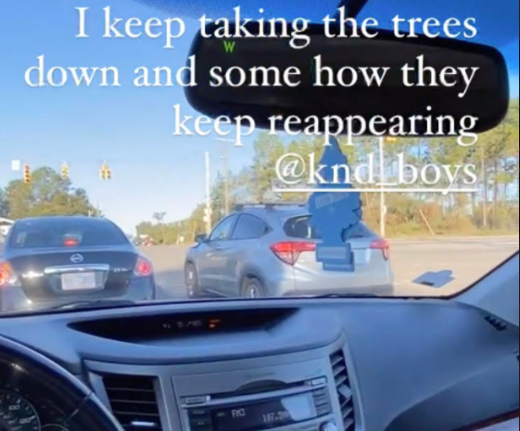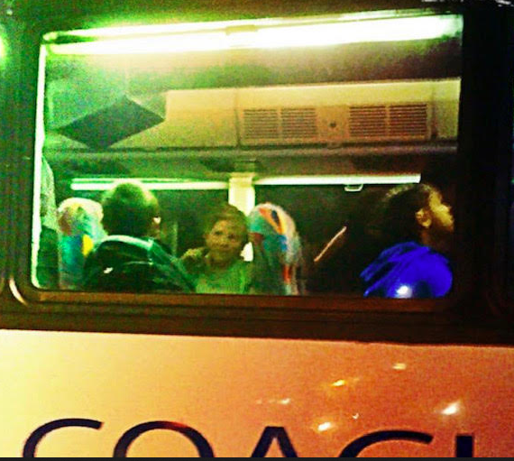 Carowinds Middle School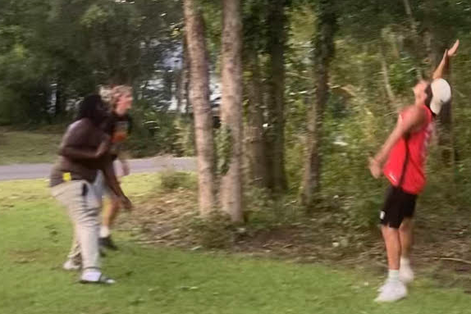
16th Bday first time that many slept over