Nov 26 Thanksgiving. So I am hosting Thanksgiving at my house with the Fords coming and Uncle Greg and Megan his girlfriend. So of course I had to power the exterior of the house. :)
I’m gonna attach some pictures. It was great weather and we kept it politically correct by having it outside. The food was really good and everyone cooked their speciality. Amy and Greg even a few days after were like that was so much fun. We have not done Thanksgiving at Home in 5 years so it was nice to relax and be home. Your call that evening caught me off guard, I am glad you were able to talk to friends and Angel. I want you to know anything you sign up for financially can be changed at a later date. Uncle Greg said you most likely signed up for thrift savings which starts your retirement fund. I am also pretty sure the military matched what you put in as does most employers. Don't stress over this, you have zero expenses right now.

Nov 27 So Sophia and I were doing a little balck friday shopping on lululemon and we bought a couple items for Angel using your Wells Fargo account for christmas. I figured you would not mind and everything was priced crazy cheap. I picked up Angel today and took her to lunch downtown at Slice a Life we talked a lot and you know me I just was very motivational and positive. I guess all her girl friends are doing different things around the holiday and she doesn't want to spend time with the boys without girls with her. Uncle Greg and Megan met us when we were done with Lunch and we shopped around downtown and then her mom picked her up to go black Friday shopping. Angel was super sweet and made a point to step outside and chat it up with Uncle Greg while Megan and I were in a store.

Nov 28th Sophia and I did a little Holiday shopping trying to step up the Christmas Spirit. Early afternoon she had me drop her at Grace Smith's house. They ended up at the beach walking around randomly with some boy named Broady who’s mom owned the Daycare Milestones. She insists everyone does this their age. I wish you were a text away and I could be like is this ok? I picked them up around 9:30pm and then I went to bed and I woke up to Sophia standing over me asking if she and her gf could ride bikes to Marsh Oaks. It was 1:30am. I was like hell no! I was like if a boy wants to meet up his ass needs to come here not you go there. Secondly, meet up in the daylight. God HELP ME! I told her she gave me no window of down time between your crazy behavior and now her’s. Uncle Greg and Megan left today. He is supposed to be back for Christmas with Mathew.

Nov 29th Got the tree decorated, Sophia says it looks the best it's ever looked. Most likely because everything kinda matched lol. Roxi is trying to climb it daily just to add to the excitement of our quiet house. Luckily we are using the Fake Tree and pine needles are not going everywhere. Your sister is so proud of our decorations she asked if she could have a boy girl christmas party. I agreed as long as it wasnt on 12-18-2020 which will be when we can watch a graduation live from home. Praying no setbacks!!!! Grandpa bought you a really nice Military grade watch for Christmas you Know he only buys the best. The brand is Citizen. He mailed it to me so I can get to you as soon as I can send packages to you. I have no idea what it looks like. So don't buy one hang in there with the crappy one.

Nov 30th Hearing from you more often has really given me some calm Im not as sad missing you and crying all the time lol Remember before you graduated I played that podcast with a Mom talking about her son growing up and moving on is like the longest break up ever lol now you probably get what I was trying to tell you. Listening to you want to be successful and rank higher is exactly what I need to hear. This isn't Harris teeter, they give you the opportunity to move forward often! No that Harris Teeter is a good comparison lol On another old job, Savage has put out some cool T-shirts and hoodies with the American flag I wonder if you inspired it:)
Sophia Just texted me and She and Kiera made the Laney JV cheer squad. Only took them two weeks to announce lol They are over the moon Surf besties to now cheer too!

I love you kid! Some days this all feels very surreal like I can't believe you are where you are and the amazing things you are doing. I pray you have no setbacks due to covid or anything you are so close. Remember you were made for moments like Battlestation you will do amazing. Perform your job safely, be a leader when needed and be led when needed. I can't wait to hear your stories and see you in your uniform.

Love Mom
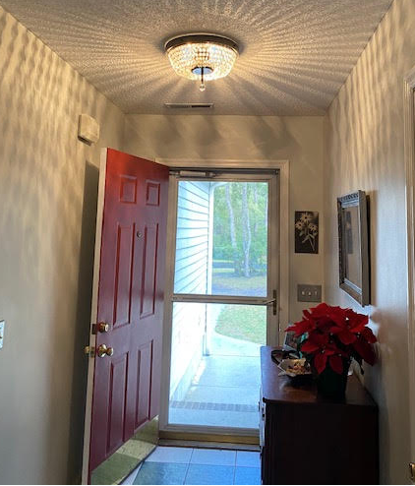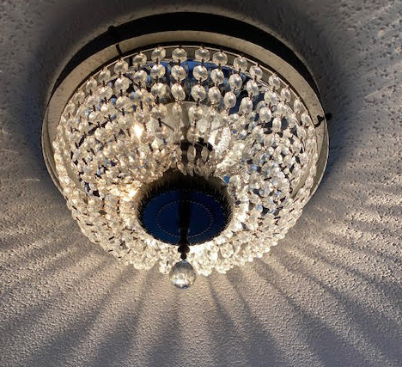
Uncle Greg hung this light fixture for me! It is so bright the foyer no longer feels like a dungeon. 