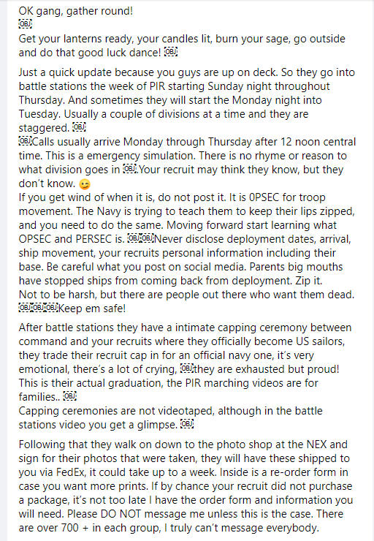
12-9 Wednesday This has to be the longest week ever! I got this alert last night and sent it out to the family. Then Uncle Greg sent me this text this morning which with him I don’t know if its cryptic or he really had a dream lol.
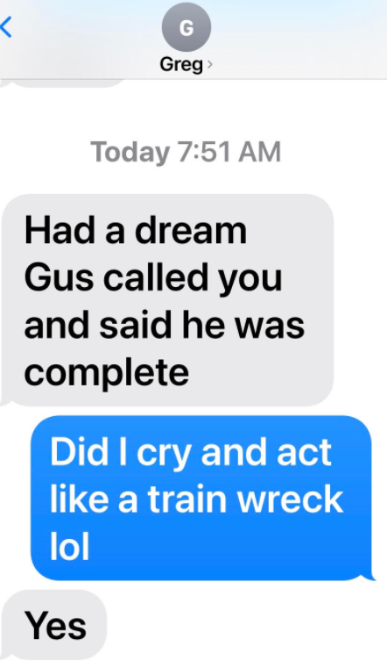 see brothers/siblings still make you crazy even at my age. Everyone is praying in my PIR 12-17-20 Division 053-064 Group on Facebook. Gia, Nico’s mom asked if I had gotten more letters from you this week. She really misses her boy! Just like me! So lucky we have connected and I have a Mom who understands how I feel with you being in Great Lakes. I’m trying to finish up my Christmas Shopping this week so if all goes well and your moved to THRU waiting on School you can get packages and I can send you gifts. You know Nana is going crazy she can’t send you food. She keeps asking when can I send him a package with all his favorites. Angel tested me yesterday on behalf of Jake lol asked if I still had the drinking cooler from your going away party. I was like Jake didn’t text me because he didn’t want me to know they were going to have a party. Angel told me something was like a kick back party was happening. Your sister was like they are going to get thrown out of that apartment in a month or two lol you know she is such the rule follower. I saw this image today on Feds story thought it was funny, yes I know eggplants mean something sexual I just have to look it up..
I told my friend Bradly today I have not turned into an alcoholic stressing over you in bootcamp I told him its like Im not as stressed now because you are not making me crazy on a daily basis coming and going with some new crazy activity going on at my house. Now I just miss you! I told him its like a toxic relationship I can’t give up hahahaha. But don’t worry your sister is slowly turning into a mini Gus god help me. At least girls are cleaner and don’t smell.
Im not sure when you will get this letter but we love you and we are all rooting for a successful Battlestation! I think Uncle Greg and your Dad wish they could be there going thru it with you. Perform Safely, be a leader when necessary and be a loyal teammate. You will do awesome.
Love Mom!
