Dec 8th Tuesday They have told us to stop writing letters around Dec 10th because you will be moved somewhere else by the 18th. I'm gonna keep writing them through the end of the week. You know I don't like rules:)

I have invited the boys over on the 18th to watch your graduation. At first, they were not responding to Angel then she sent a second message Sunday and they all said yes they would come. We were both going to lay into them. Lots of rumors that graduation may be earlier.

Sophia had her first Laney practice last night. It was nice to be back on campus picking up a kid. Ran takes her to and from so I'm not stressed in the mornings. Work has been super busy no change there.

We miss you making us crazy coming and going eating all the food and complaining we have no food:) I go to the grocery store once maybe twice a week. Laundry is only like two loads now it’s amazing how much clothes you would go through a day lol.

My plan when you get to school is to decide personal items you need me to ship to right away. Air pods, blanket, specific shoes you miss? I know you think you have a job and are all grown up going through this process but I am still your mom:) I still need to feel needed lol so you need to bug me to do things for you even from wherever you are.

I am not sure if you will get this letter before battlestation. But I am praying every day you are not stressed and just driving forward to your final test. You will do great and then you get to finally rest:) and sleep:)

They gave the Vaccine to a 90-year-old in England today and televised it. Sounds like they will start releasing it next week. Uncle Greg's girlfriend is slated to get the 16th because she is a trauma surgeon. Can't wait for you to meet her. She is very chill; she actually makes your uncle look foolish lol

Babes I love you and you are not missing anything here! You are moving more forward then any of us! Can't wait to see you soon even if it's on a YouTube recording.
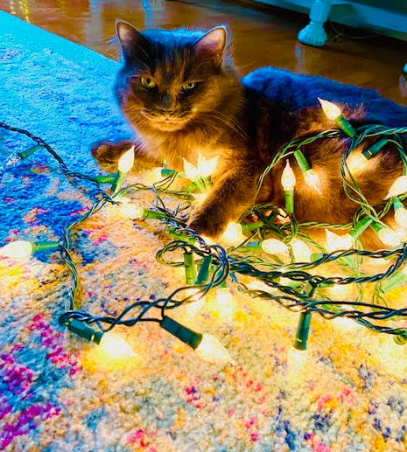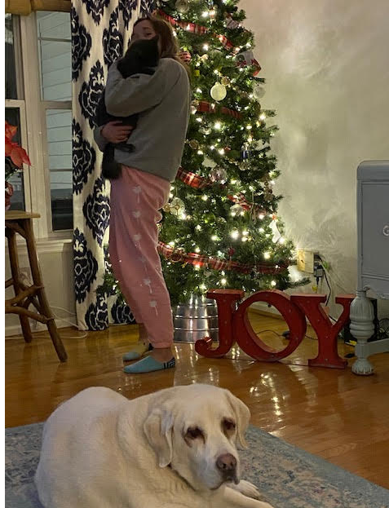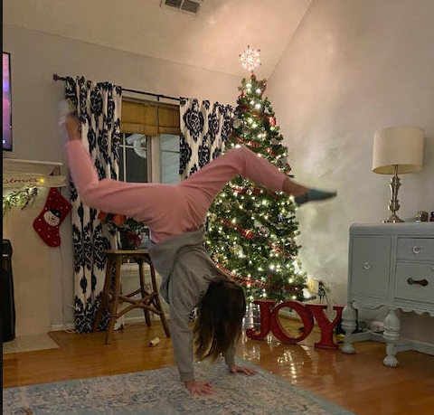your sister is doing a vlog channel on YouTube with her friend so you can catchup on her fun freshman life when you get your phone 