Dec 1st, So your sister is officially a Laney Buc cheerleader. Something she has wanted for years and probably something so odd to you because it's hard for you to imagine her going to High School. Some Days it's really hard watching her grow up being bitchy to me around her friends and just too cool for anything I suggest. You went through this phase but you didn't start doing it until your Junior year lol. When you are able to communicate with her again please tell her the stuff she needs to know about boys and the stupid stuff they pull with girls. Also tell her not to be needy or to be aggressive with boys let them chase her. Anything I say is just quiet noise in her mind just like it was to you. So, your sister wanted a wetsuit for Christmas and of course I can't find anything she likes because it's all too plain, boys wear plain black not girls. She also wants vans booties. Do I love she loves surfing yes it keeps her active do I wish you had loved it more YES!. Maybe you will find it again as a hobby. You loved the water and being in the ocean not sure why surfing wasn't fun to you. I got more letters from you today at lunch. They were soaked because it had poured down rain. Angle stopped by my office with her dad to pick up her letters. I honestly think her Dad thinks you're doing cool stuff. He actually smiles and talks to me normally now lol and he made the effort to bring her by my office. I know you worry if she still thinks about you or misses you. For God sakes that girl hung on to you when you majorly screwed up over and over. I think she understand you both are young and this will be hard but at the same time you would be stupid not to think you are her best friend and she is yours. I know you have your boys and she had her girls but you two kind became each other confident outside of those circles. So, stop worrying about whether she misses you or thinks about you! She misses you like crazy! Also, she did say something to me once that she didn't feel like people took your relationship seriously. I told her that no one knows what goes on in a relationship except the two in it! Everyone thought your dad and I were perfect together no one knew he slept in another room and struggled with insomnia and verbally abused me daily. I decided when you guys were young that you didn't need to live in that chaos. My parents were so unhappy when I was growing up my dad slept on the couch and I couldn't stand the thought of you and your sister not knowing that relationships are people who truly invest in each other and love each other. In the few relationships I have seen you have you are different then your dad because you have been loved properly by your mom. I see you enjoy relationships for the companionship not the need to not feel alone.

Dec 2, I sent pictures of your letters to uncle Greg and Grandpa. Uncle Greg said to tell you he has done more watches then you have SNAPS lol. Uncle Greg has paid his dues, he did four years at the Naval Academy which was like 4 years of boot camp with college courses. You should think about once you get through A school trying to take college courses in your spare time, at least the primary classes you need before selecting a major. Your Grandpa was a mustang not sure if you remember this term but it is when you go enlisted to officer. There are lots of options for you to elevate your career in the Navy, you are VERY young compared to a lot of people around you and have a lot of time to become very successful! Also, Grandpa says you're popping a lot because you are eating a ton of vegetables. You are not living off fast food! I bet your skin has no issues because you have cut out all the crap in your diet. Remember this when you're done! I would tell you all the time it's what you're eating and drinking all the time that impacts your skin and your body!

Dec 3 Wow we are 14 days away from graduation at bootcamp. I can tell all the parents on my site that I read are getting restless praying for no setbacks. This time with you there has definitely challenged me as your mom. I have tried to stay very busy with nutty projects next up your room :) tearing up the carpet on the steps, painting the wood on the steps and adding new carpet upstairs painting and fixing the walls and that crawl space. Sophia keeps telling me the items you wanted done to your room. Lol I want it to be a space that is comfortable to sleep in when I have guests and when you return for visits. Sophia has been taking kids up there to play xbox and the space truly feels huge since we cleaned it. Angel helped me clean out your drawers and fold everything she was like he has one empty drawer now lol.

I know you think your Nana and Dad will be the proudest of you when they see you in your uniform. I guess you think I must have known you are exactly where you need to be! I have always seen success in you and the crazy amount of energy that just needed to be focused in the right directions. All your life if you just practiced a little or you just studied a little you always did well. I have never doubted you were not smart or able to do anything you put your mind to! It's you who had to find your path. I am also proud of you but prouder that you are finding focus. I kept waiting for you to come to me and tell me you didn't want to go and that would have been a very difficult conversation. Sophia said if that had happened and you hadn't gone you would have regretted it the rest of your life:) I am incredibly proud you made this choice to serve your country and you never looked back. I know it was incredibly hard leaving all the comforts of home and your friends and Angel. But I have said it a hundred times. My home is always your home and your friends and Angel will always have a loyalty to you that will never change. Babes I love you and I Know this week ahead is going to be incredibly challenging. I have no doubt under pressure you will do absolutely amazing. Tell your bunk mates they will too because you have their back and they have yours.

Love you Mom.
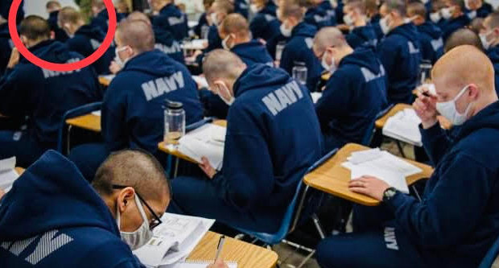
Is that you!? You know I am trying to spot you in any picture this was during Pdays.
