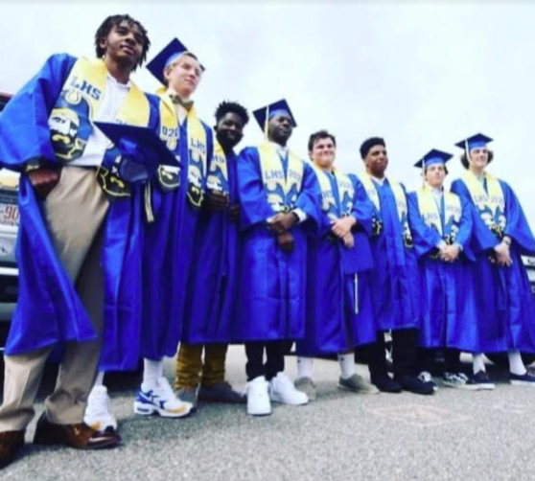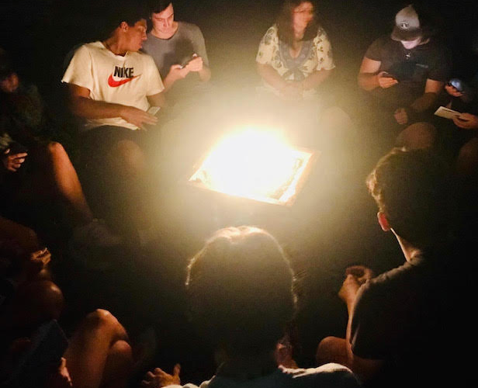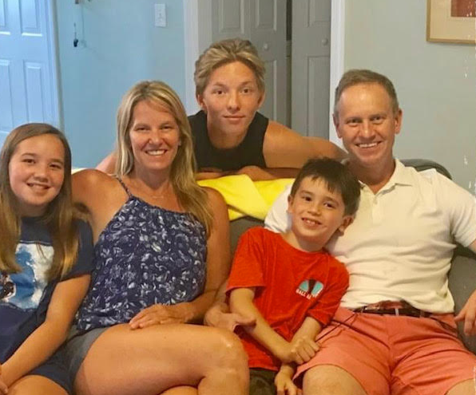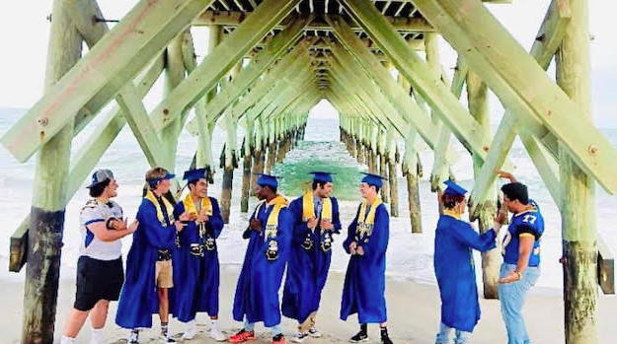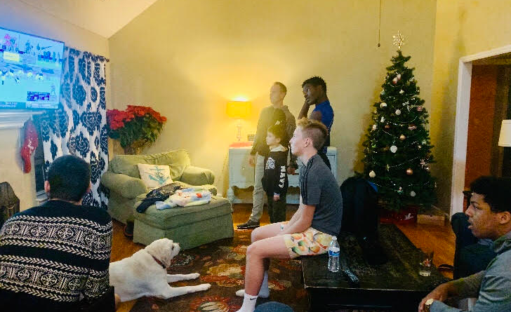Army Navy game last year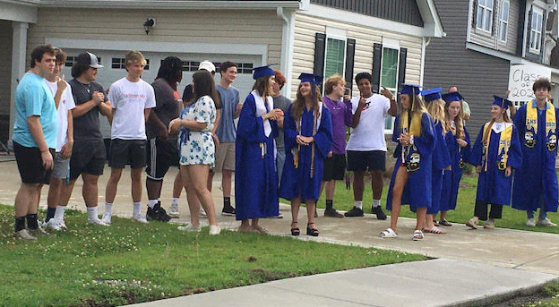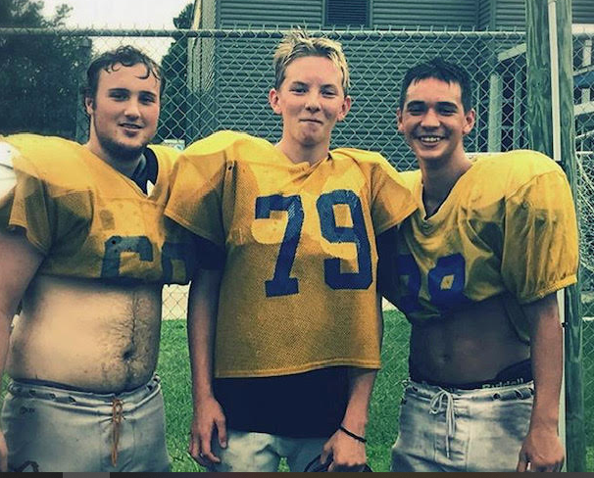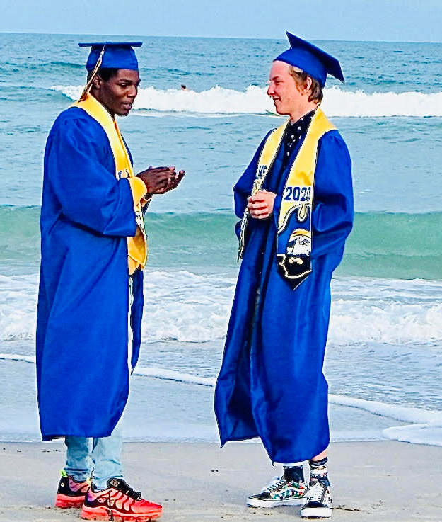

Dec 10 Not sure if I told you Sophia and her friends started a vlog channel. 4 of the girls vlog every day and they have got Calvin Kiera’s brother editing it for them which is awesome he makes it so more funny and does focuses on one person more than the other. At the end of each video he attaches a random photo of himself. So last night Sophia let me watch it and she is sucking helium out of a balloon and trying to vlog at the same time, at one point she is like beating the balloon to get more helium out. I was like Sophia they are going to come arrest me and due to you looking like a helium addict lol. So, when out get done at Bootcamp and are bored you can watcher channel and get caught up on her life lol. Sophia is having a Christmas party Friday it making me a bit crazy because only 2 boys RSVP to come and the other have lame no showing reasons. What is wrong with boys at this age to not want to go to a boy girl party. So, it will be like 8 girls two boys and she keeps insisting I need to invite a friend to come over. The thing is all my friends have kids and she didn’t invite any of their kids lol and she told me I could invite my male friend from around the corner because that would be weird. Sure annoyed. I invited Angel and Jacklyn to drop in so will see if they do.
Outside of that just trying to get some Christmas shopping done. I want to get things I know you need and want when you get to your own space but I guess I have discovered I cant read your thoughts from here we were not given some scifi telepathic gift.
Evan texted me last night and asked if he could stop by and get the orange cooler. I said sure Its not like I’m going to need it for anything and you won’t need it until your home. I guess Mike K bought it? I know you miss the boys but you are really doing so more and learning more then they could ever imagine. You would be so bored at home. The gov just issued another curfew for 10pm all restaurants need to be closed and stop selling alcohol at 9pm. Very strange they must think covid spreads after 10pm. Cases are high and hospitalization but New Hanover County’s numbers are super low. The weather is really off 30 one day 70 the next so people tend to get sicker when that is happening so I have no idea what to trust. Vaccine is out in the UK and hopefully out in the US next week. It has already been delivered to hospitals just waiting on the FDA sign off. First responders will be the first to get the Vaccine then the elderly. Not sure where the military is on the list but Uncle Greg will most likely update us. Trump is fighting still to win the election; he is currently going after the electoral’s not being able to vote. Biden’s son is also now under investigation.
Can’t wait to see your face! Expect me to cry lol! I’m not as bad as I was the first few weeks but I still get emotional. Be glad I show emotion means I love you. I’m not sure if you will get this before or after Battlestation. But you will do fine you have done great up to know! Better than I ever imagined. We LOVE YOU and Miss you! Everyone!

PS. I wrote 4 letters this week M-Thur. I want you to be getting mail up to the end.

